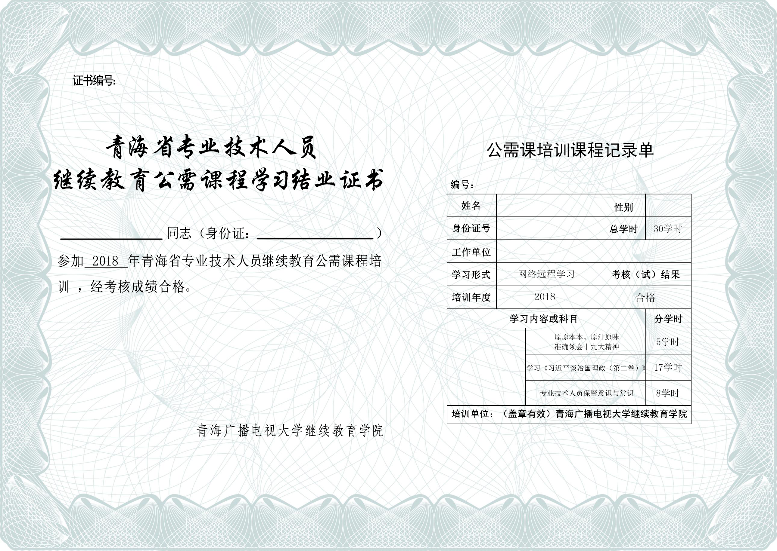

|  |  |  |  |  |  |  |  |  |  |
| --- | --- | --- | --- | --- | --- | --- | --- | --- | --- |
| |  | | --- |   certno | | |  | | --- | | |  | | --- | | |  | | --- |   certno |  |
| |  | | --- |   fullname  qrcode | |  | | --- |   idnumber  C:\Users\Administrator\Desktop\青海电视大学.png青海电视大学  certsenddate |  |  | |  | | --- |   fullname  idnumber | |  | | --- |   sex |
|  |  | |  | | --- |   C:\Users\Administrator\Desktop\青海电视大学.png青海电视大学companyname  qrcode | |
|  |  |